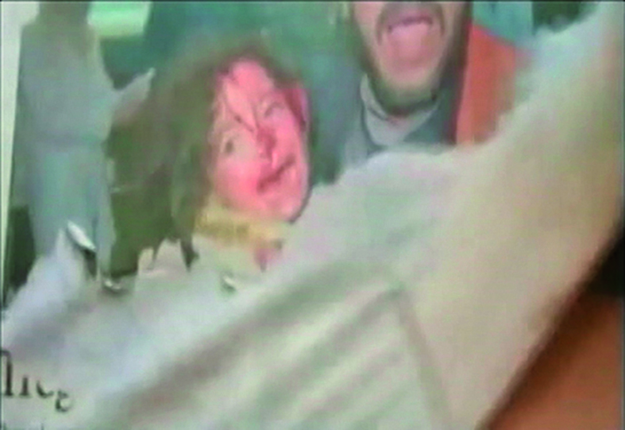

(…) In her videos, the repetition of the gesture and its sound gives the impression that the intention of the artist is to wipe out all the newspapers in the world. We might also think of: wiping out the memory of the world. But the interesting aspect is that this fadeaway indeed has a memory effect. By attempting to wipe out / forget the mounds of information suffocating us and subjecting us to their rules, Danziger makes us lighter. She broadens our horizon and expands our area of play and action (…) The gesture of ripping away letters and, to an even greater extent, tearing pictures out of the newspaper is delicate and brutal, aggressive, at one and the same time. It is as though we cannot oppose the strength of this information and everything that it means, except through destructive and opposing force. Danziger counterbalances the diseased iconophilia of our times with a healthy and welcome iconoclasty. But her gestures with the newspapers are ripping and removing icons, rather than merely destroying them. Like Freud, she digs, and her ‘cure’ for the newspaper is not through words (a talking cure), but rather its reduction to new images and its insertion into a new hieroglyphic narrative that is verbi-voco-visual. Her ‘prayer’ is the obsessive peeling-off of the newssheet. This is a gesture that is both delicate and ritual, repetitive and violent: the artist injures the page. She removes its skin. This wound is a way of materializing the violence that is both masked and showcased equally by the words of the newspaper. Public Diaries (Diários públicos) faces up to the omniscient presence of daily newspapers and the crushing of the private by the public. Through her body and gestures, the ‘ripping the newspaper into strips’ performance restores the human, the individual, where before there seemed to be room only for mere information. “Rip up your newspaper and be (re)born into life,” is what the artist seems to say to us; once again, ‘ripping the newspaper’, depleting it, means turning the information garbage into art; it means re-signifying the instrumental rationality of the ends into pure means, the ‘purposeless purpose’ of art.

(Uma arca para a memória; Márcio Seligmann-Silva in Leila Danziger: Todos os nomes da melancolia, Apicuri, 2012).

